Newtons first law is……

A body continues in its state of rest or state of motion unless acted upon by a force”. This law is also referred to as the Law of Inertia.

Inertia refers to an object's resistance to changes in its state of motion. The more mass an object has, the more inertia it has.

**Soccer**

When a soccer ball is stationary on the field, it remains at rest until a player kicks it. This is due to its inertia; the ball resists changes to its state of motion. Once kicked, the ball continues to move in the direction of the kick until forces like air resistance or friction with the ground slow it down.

**Golf**

When a golfer swings the club and hits the ball, the club’s inertia means it will continue moving in the direction of the swing unless acted upon by the force of impact and the golfer’s follow-through. After hitting the ball, the ball will continue to move in the direction of the swing due to its inertia.

When else is it used in sport, nonspecific examples:

**Starting and Stopping**: Athletes need to overcome inertia to start moving from rest or to stop quickly. For example, a sprinter must exert a significant force to overcome their inertia at the start of a race.

**Maintaining Speed**: Once moving, athletes need to manage their speed and direction against inertia. For example, a cyclist maintains a high speed on a straight path due to inertia, but must apply force to change direction or slow down.

Newtons second law is……

The acceleration of a body is proportional to the force applied to it and inversely proportional to the mass of the object”. This law is also referred to as The Law Of Acceleration.

***Momentum*** is a measure of the amount of motion possessed by a moving body. It is the product of mass and velocity (Momentum = Mass x Velocity) An object can only have momentum if it is moving.

The greater its momentum, the more force that needs to be applied to either stop or slow the object down

When is it used in sport

A 70 kg rugby player is running at 6 m/s when they collide with a 60kg rugby player who is running at the same speed.

Explain the principle that describes this collision and describe the result of the collision.

Momentum is a fundamental concept in physics that describes the quantity of motion an object has. It is a vector quantity, meaning it has both magnitude and direction. Momentum = mass x velocity, with mass being the amount of matter measured in KG and velocity being speed of the object measured in meters per second.

Since both players are moving at the same speed but have different masses, their individual momentum is different. A player with more mass will have more momentum if moving at the same velocity as a lighter player. In this case, the 70 kg player will have more momentum than the 60 kg player because their mass is greater.

Impulse is….. Impulse is the application of force over a period of time to change the momentum of an object. Impulse = force x time. Where force equals the object’s mass multiplied by its acceleration, and time equals the length of time for which the force is applied to the object.

Most common exam examples…..

**Kicking a Ball**: When you kick a ball, your foot applies a force to the ball. The longer your foot stays in contact with the ball, the more impulse you give it, and the faster the ball will go as you increase the time the force can be applied.

**Catching a Ball**: When you catch a ball, your hands apply a force over the time it takes to bring the ball to a stop. The impulse in this case is what changes the ball’s momentum from moving to stationary you are absorbing the force over a longer period of time.

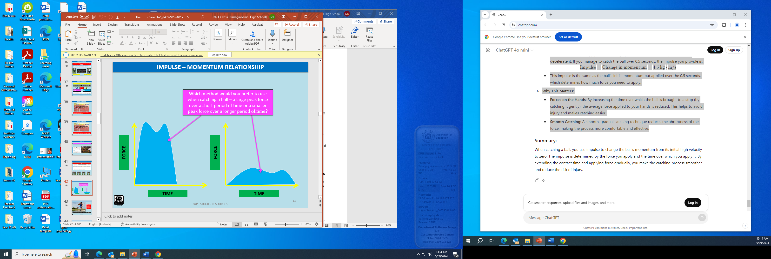

Discuss the principles of impulse and momentum and how it can relate to catching ball.

When catching a ball, it’s momentum is determined by its mass and velocity. A cricket ball would have a lot of momentum because of its high velocity off the ball and its higher mass compared to a tennis ball.

When you catch the ball, your hands apply a force to the ball to stop the ball. If you catch the ball quickly, the force applied needs to be very large to stop it in a short time. If you catch it more gradually, the force can be smaller because it’s spread out over a longer time.

Impulse is the application of force over a period of time to change the momentum of an object. Impulse = force x time. Where force equals the object’s mass multiplied by its acceleration, and time equals the length of time for which the force is applied to the object.

Impulse causes a change in the ball’s momentum. When you catch the ball, you’re changing its momentum from its initial value (high velocity) to zero (when it’s stopped).

By increasing the time over which the ball is brought to a stop the average force applied to your hands is reduced. This helps to avoid injury and makes catching easier.